Brachify User Manual
Contents
1. Treatment Planning – Varian 2
2. Treatment Planning – Elekta 3
3. Setting up Brachify for the First time 6
4. Using Brachify 9
4.1. Load DICOM file 9
4.2. Import 10
4.3. Display 11
4.4. Cylinder 12
4.5. Channels 13
4.6. Tandem 15
4.7. Export 18
5. Layout of Brachify 20

Treatment Planning – Varian
  - Line up Cylinder and place Central Axis.
- Create a straight-line needle and place it along the central axis of the cylinder.
- The central axis must be labeled “Central Axis”.
- The Central Axis will be used to orient all the other needles in Brachify so place it as accurately as possible.
- The tip of the needle should be at the tip of the cylinder.
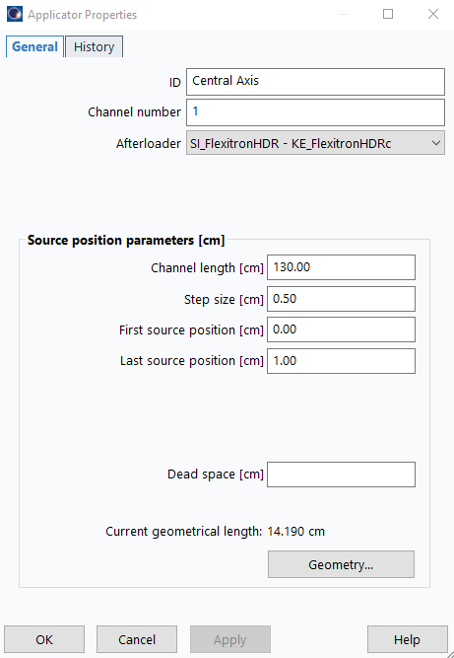
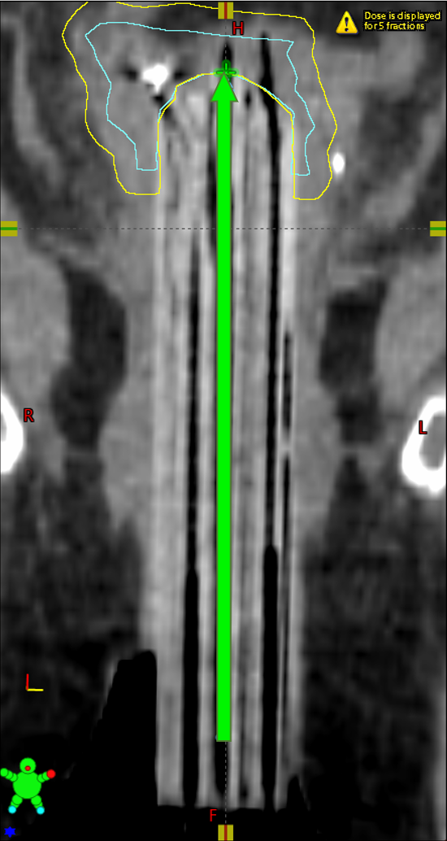
- Ensure the dwell times for the Central Axis are set to 0. The Central Axis needle will not be used in the 3D model.
- If you want to have a central needle, you will need to place another overtop.
  - Place the other needles in your plan
- Ensure no needles intersect and then save your plan.
- If you would like to use a needle channel to provide a direction for the tandem, ensure it is labeled “Tandem”.
  - Go into the Dose Matrix Export and add the structure set to the export. Dose is optional. 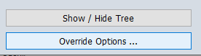
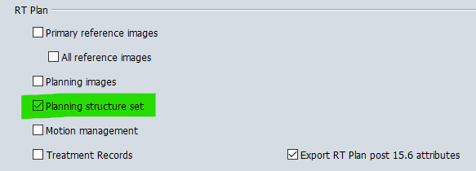
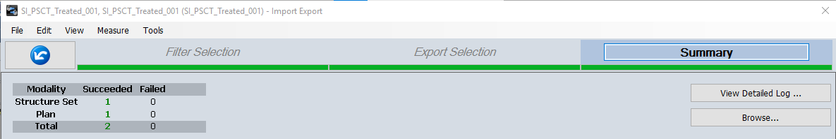
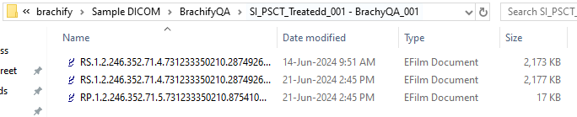
Place files in a folder of your choosing.

Treatment Planning – Elekta
  - If you are using implant models:
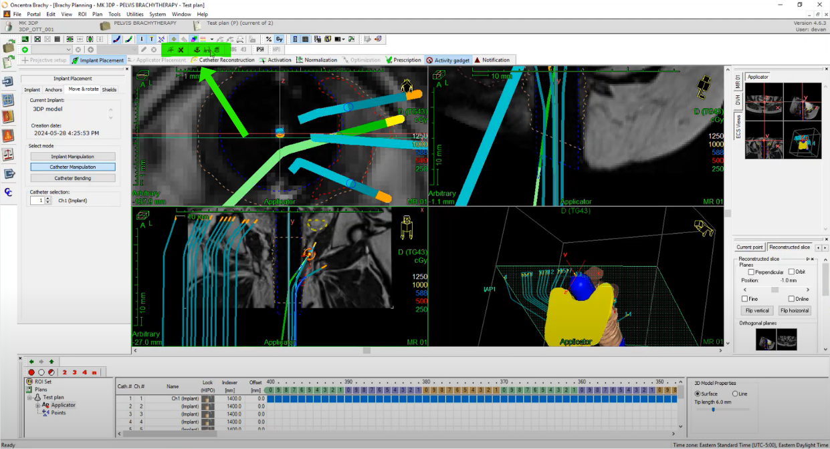
- You must have a license which allows you to use the implant model portion of the software. (This feature is not in Elekta by default.)
- Hit the “+” button and then select the implant model.
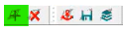
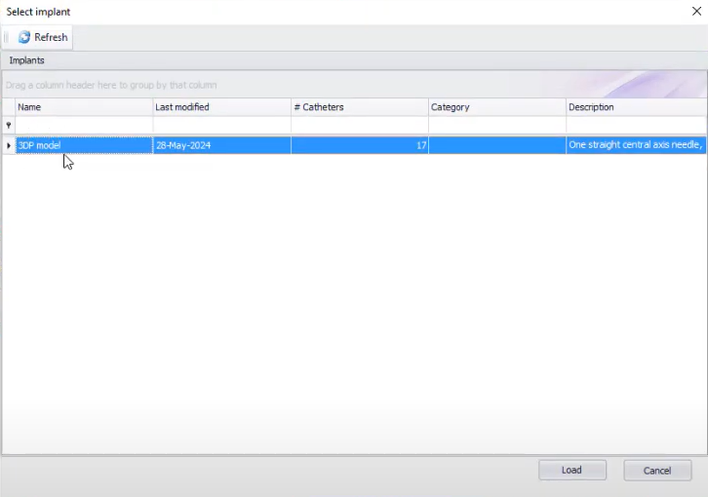
- (Ensure the model has one straight needle labeled Central Axis which is given channel number 1)
- Note: The implant model must be approved by Elekta before Elekta software will let you use it.

  - Line up Cylinder and place Central Axis.
- Place a straight-line needle along the central axis of the cylinder.
- The central axis must be labeled “Central Axis”.
- The Central Axis will be used to orient all the other needles in Brachify so place it as accurately as possible.
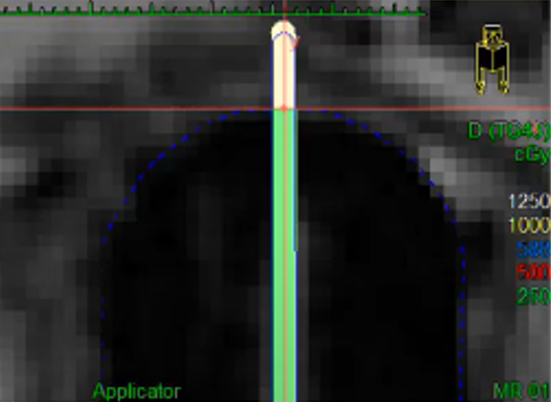
- The tip of the needle should be at the tip of the cylinder.
- Ensure the dwell times for the Central Axis are set to 0. The Central Axis needle will not be used in the 3D model.
- If you want to have a central needle, you will need to place another overtop.
  - Place the other needles in your plan
- Ensure no needles intersect and then save your plan.
- If you would like to use a needle channel to provide a direction for the tandem, ensure it is labeled “Tandem”.
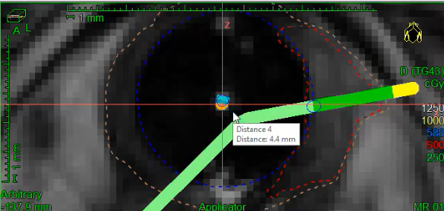
- Ensure the Central Axis is channel 1 and all further needles have channel numbers in ascending order (2, 3, 4, …)
  - Go to the File tab and go to Export and then press DICOM Format.
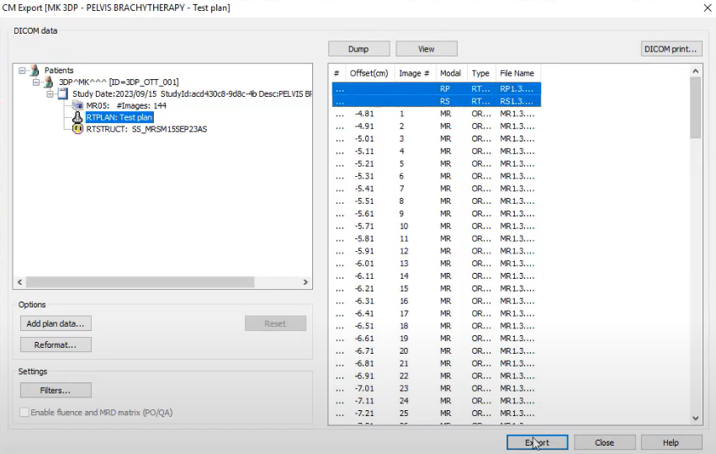
  - Select the RP and RS DICOM files and then click “Export”.

Setting up Brachify for the First time
  - Download Brachify.
    - Go to https://github.com/brachify/brachify-release/releases
    - Choose the most recent version of Brachify (which will be the one at the top of the list) and click Assets.
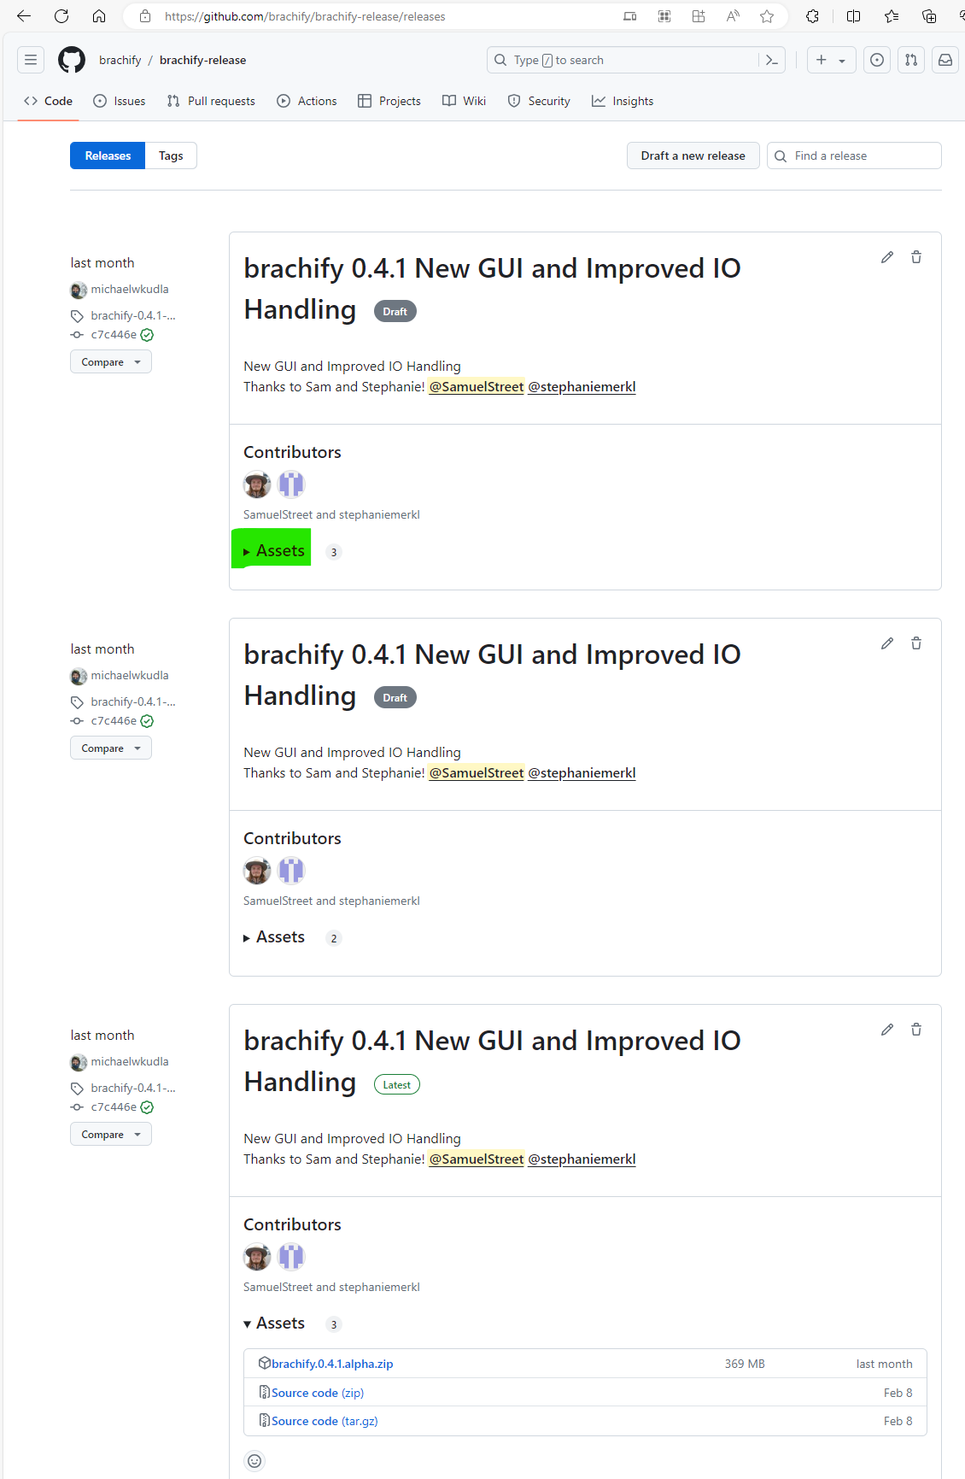
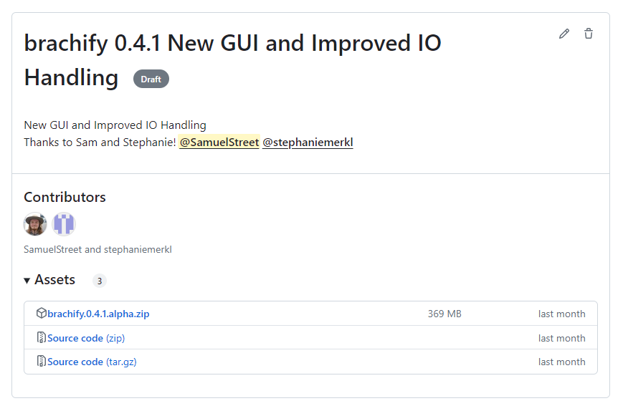
    - In the Assets tab, click on the file named brachify.#.#.#.version.zip.
    - This will download Brachify to your downloads folder.
  - Right click on the zip file in your downloads folder and press Extract All.
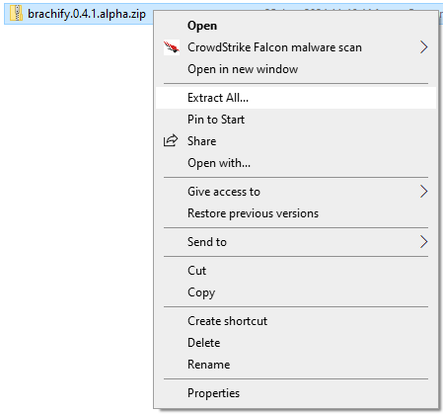
  - Select the folder where you would like to store Brachify.
      - By default, Brachify will be stored where the zip file is located.
  - Click Extract and wait for extraction to finish.
      - A new folder named “brachify” will be created in the selected location. This stores the program files for Brachify.
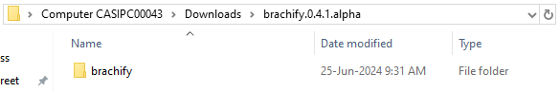
  - Navigate to the new brachify folder and double click on the new file, then double click on the Brachify folder inside.
  - Go to the brachify.exe file.
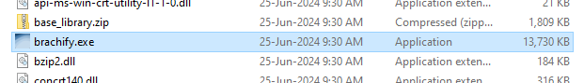
  - Create a Shortcut.
- It is recommended to make a shortcut of the brachify.exe to the desktop or another convenient location. The shortcut or brachify.exe can also be pinned to the taskbar.
  - Run Brachify.
- To open Brachify, double click either the brachify.exe file or the short cut.
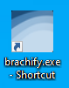
- If you receive a security warning, either click the Run button, or, if you would like to not receive this security warning again when running Brachify, uncheck the checkbox labeled: “Always ask before opening this file” and then press Run.
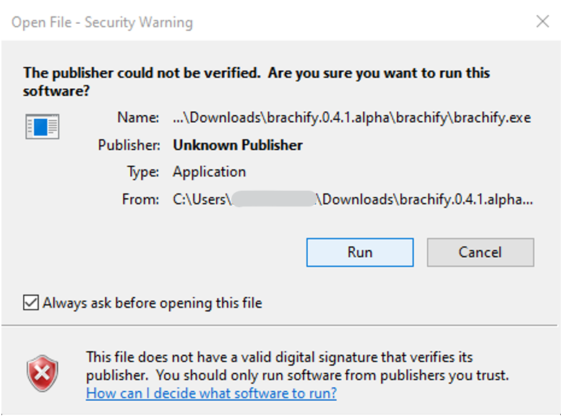

Using Brachify

Load DICOM file
    - Click “Import Dicom”.
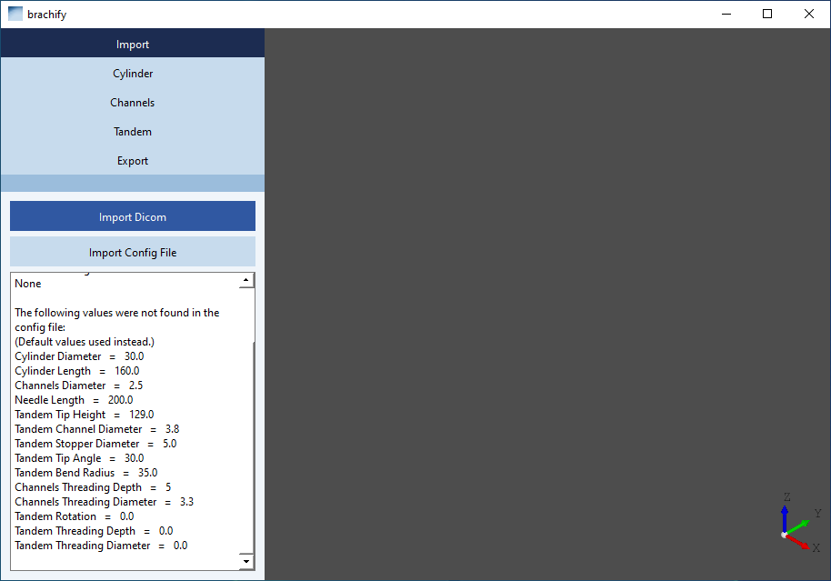
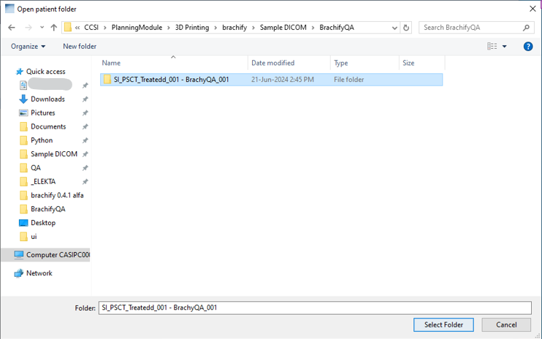
    - Select the folder containing the DICOM files you would like to import and click “Select Folder”.
    - After importing a file, you are brought to the Export view. For details on the Export view, see Section 4.7 Export.

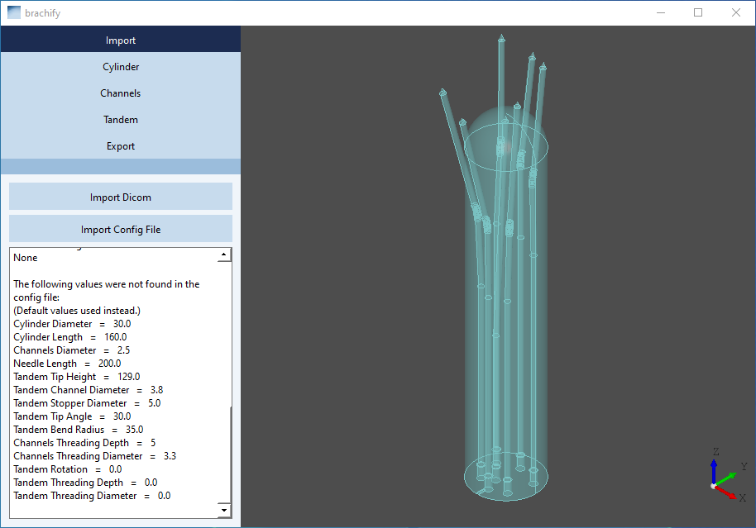
Import
Import Layout
- Import DICOM:
  - As discussed in Section 4.1, Import Dicom allows you to import a DICOM file.
- Import Config File:
  - Allows you to import a configuration file which sets default values.
  - Each time Brachify is opened, the spin box values (such as cylinder height, needle channels diameter, etc.) are set to default values. To use different values from the current values, import a “.json” file containing the desired values. Every time Brachify opens, it will use the file that was last used. To learn how to create a “.json” file for this purpose, see Section 4.7 Export.
- Information Panel:
    - Import Info:
  - File path of currently loaded DICOM folder
  - Patient and Plan Info
  - Channel Info: This will display channels as
Channel Label, Channel: (Channel #)
  - Always displayed:
  - Config file location
  - Overview of values loaded into Brachify from config file or default.

Display
- To the right of the tabs, there is a display panel displaying what the cylinder looks like.
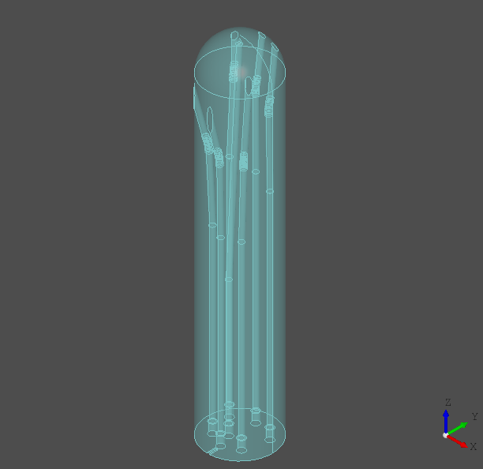
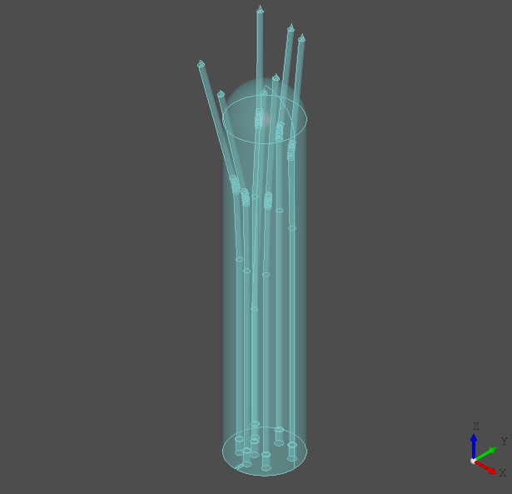
Display for Import, Cylinder, Channel, and Tandem tabs Display for Export tab
- In the Import, Cylinder, Channel, and Tandem tabs, the cylinder will appear with the channels and tandem cut-out (if applicable) visible. It is important to visually verify the channels appear as expected.
- In the Export tab, the channels and tandem cut-out (if applicable) are removed from the cylinder. This is the model which will be saved when exporting the design as a 3D printable STL file, so it is important to ensure all the channels appear as expected. Verify there are no blockages in any of the needles.
- To zoom in/out: Use the scroll wheel on the mouse.
- To rotate the image: Right click and hold while dragging the mouse.
- To pan the image: click and hold the scroll wheel of the mouse while dragging.

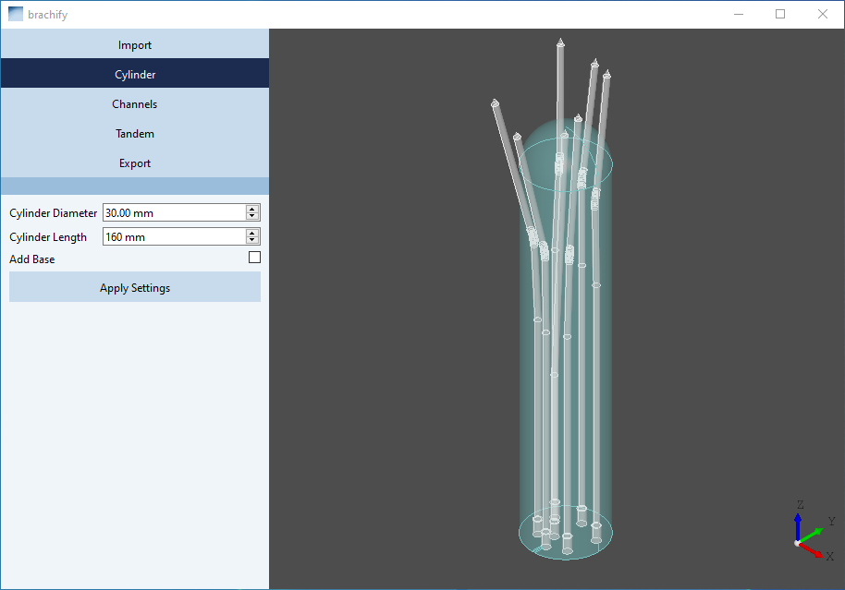
Cylinder
Cylinder Layout
- Cylinder Diameter:
  - Changes the diameter of the cylinder.
- Cylinder Length:
  - Changes the length of the cylinder.
- Add Base:
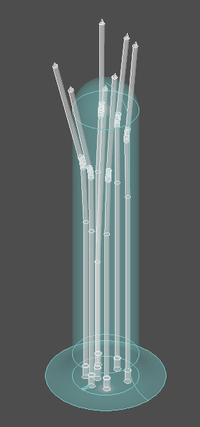
  - Adds a base to the design as depicted below.
- Apply Settings:
  - Applies any changes made to the spin box values.
  - WARNING: you must press this button for any changes you have made to be saved.

Channels
- Important: every time you change values in the channels tab and press apply, re-inspect the channels in the display. If there is an error in the generation of one of the channels, try adjusting the channel diameter or one of the other values slightly to correct the issue.
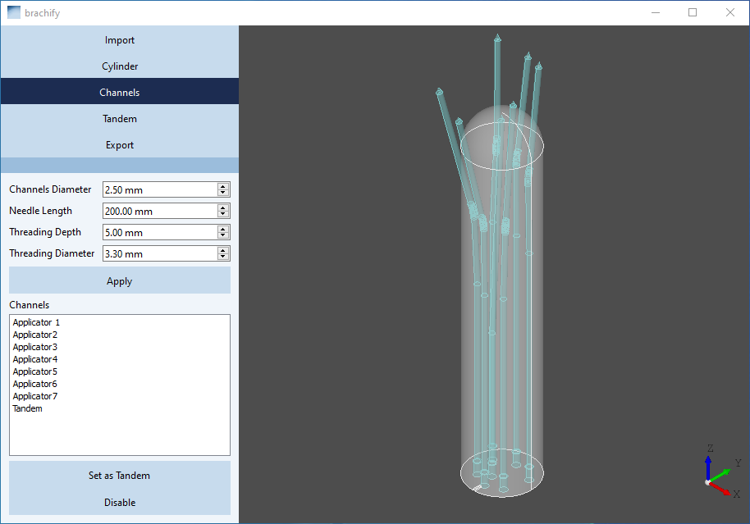
Channels Layout
- Channel Diameter:
  - The diameter of every needle channel.
- Needle Length:
  - The length of the needles being used.
(for reference sheet only, will not affect the display)
- Threading Cylinder:
  - Widens the needle channels near the base of the cylinder so threading can be added after printing the cylinder.
- Threading Depth:
  - Sets the depth of the threading.
  - A value of 0 removes threading from all needle channels.
- Threading Diameter:
  - Set the diameter of the needle channels at the base of the cylinder.
  - A value of 0 removes threading from all needle channels.
- Channel List:
  - Select a channel by clicking on a name in the channel list or by clicking on a needle channel in the display. The selected channel will change color from blue to purple in the display.
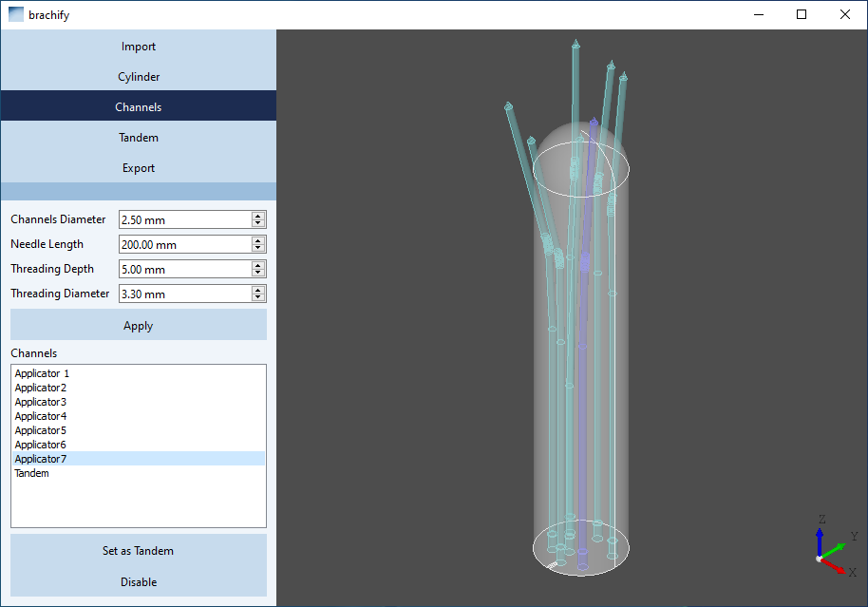
- Set as Tandem:
  - Sets the selected needle channel to orient the tandem.
    - Disables the selected needle channel.
    - Sets the tandem angle so the tandem points towards the location of the selected needle channel.
See Section 4.5 Tandem for more information.
- Disable/Enable:
  - Disable: Removes the selected needle channel from the display.
  - Enable: Returns the selected needle channel to the display.
  - A channel set as the tandem is disabled by default. It can be enabled by the user.

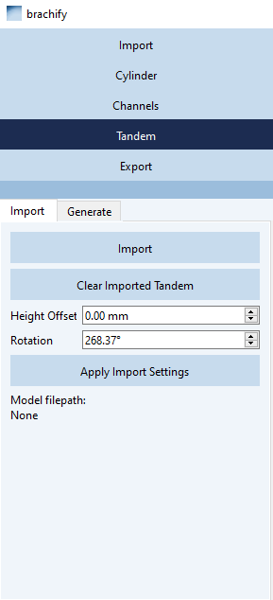
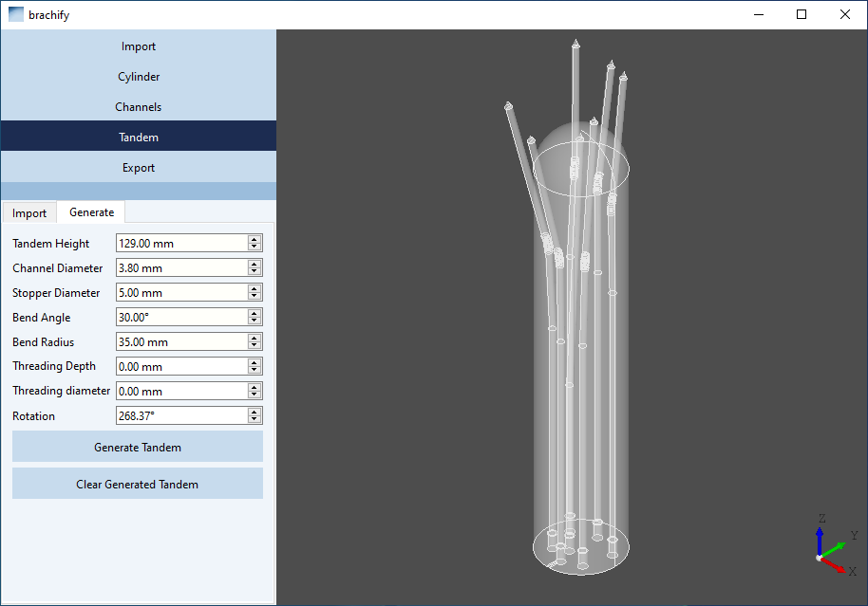
Tandem
- The tandem tab has 2 sub-tabs: Import and Generate.
- The Import tab is for importing a pre-made tandem file and the Generate tab is for creating a new tandem cut-out.
Tandem Layout
- Import Layout
  - Import
    - Select a pre-made tandem file in a file explorer.
    - Pre-made tandem files must be STEP files (.step or .stp).
    - The origin of a step file imported for use as a tandem is always placed at the base of the cylinder at the coordinates (0,0,0). Hence, when designing a tandem, ensure the base of the tandem is located at the coordinate (0,0,0).
    - No change will be made to an imported tandem besides rotation and height offset (see below).
  - Clear Imported Tandem
    - Removes the tandem (imported or generated).
  - Height Offset
    - Shifts the imported tandem up or down.
  - Rotation
    - Sets the angle the tandem model will be rotated in the (x,y) plane (with respect to the x-axis).
    - This value is also set when a needle channel is set as tandem (see Section 4.5 Channels)
    - 0° indicates the imported tandem points the same direction as in the STEP file.
  - Apply Import Settings button.
    - Applies and saves changes of the height offset and rotation.
  - File path of imported tandem.
    - Displays the file path of the imported tandem file.
- Generate Layout
  - See diagram below for illustration.
  - Tandem Height
    - Sets the height of the tandem channel; determines where the cut-out will start.
  - Channel Diameter:
    - Sets the diameter of the tandem channel.
  - Stopper Diameter
    - Sets the diameter of the stopper on the tandem.
  - Bend Angle
    - Sets the angle at which the tandem will be bent.
  - Bend Radius
    - Sets the radius of the circle used to construct the tandem (see diagram below).
  - Threading Cylinder:
    - Widens the tandem channel near the base of the cylinder so threading can be added after printing the cylinder. (cf. Channels threading, Section 4.5).
  - Threading Depth
    - Sets the depth of the threading.
    - A value of 0 removes threading from the tandem channel.
  - Threading Diameter
    - Sets the diameter of the tandem channel at the base of the cylinder.
    - A value of 0 removes threading from the tandem channel.
  - Rotation
    - Sets the direction the tandem points in the (x,y) plain (with respect to the x-axis).
    - This value is also set when a needle channel is set as tandem (see Section 4.5 Channels).
    - 0° indicates that the generated tandem points along the x-axis.
  - Generate Tandem
    - Generates tandem based on values in all spin boxes.
    - WARNING: pressing this button will remove any previous tandem (imported or generated).
  - Clear Generated Tandem
    - Removes the tandem (imported or generated).
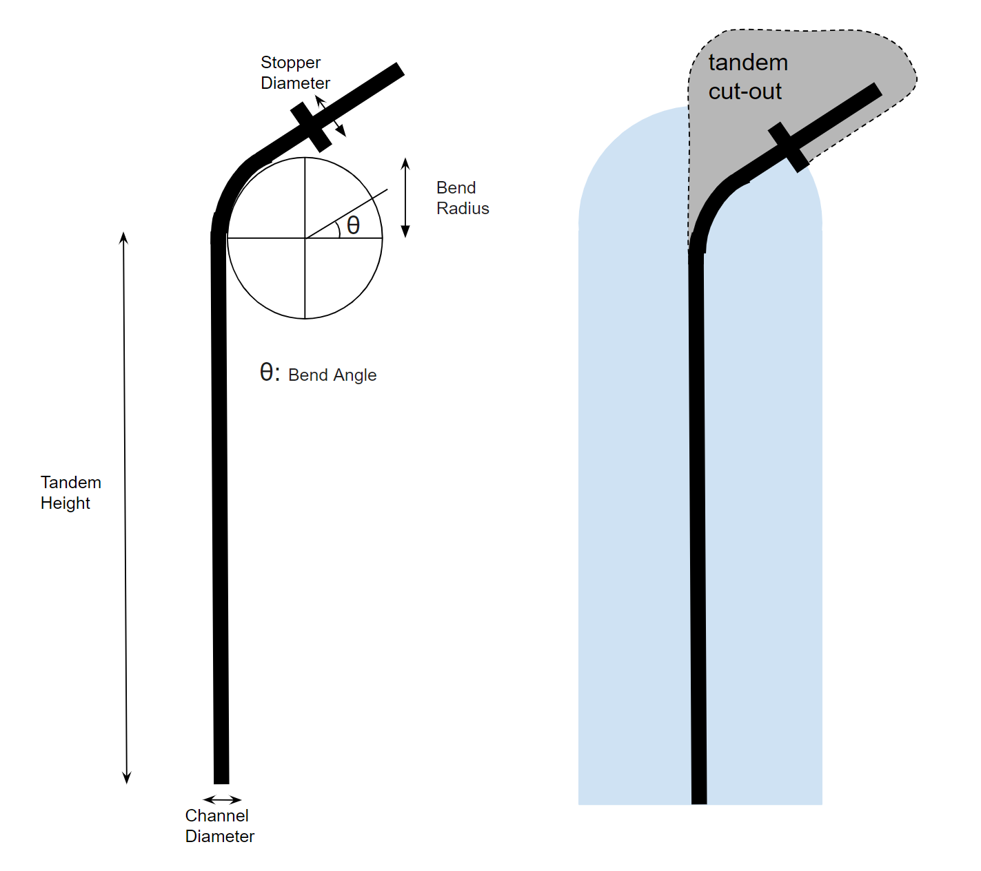
The components of tandem generation.

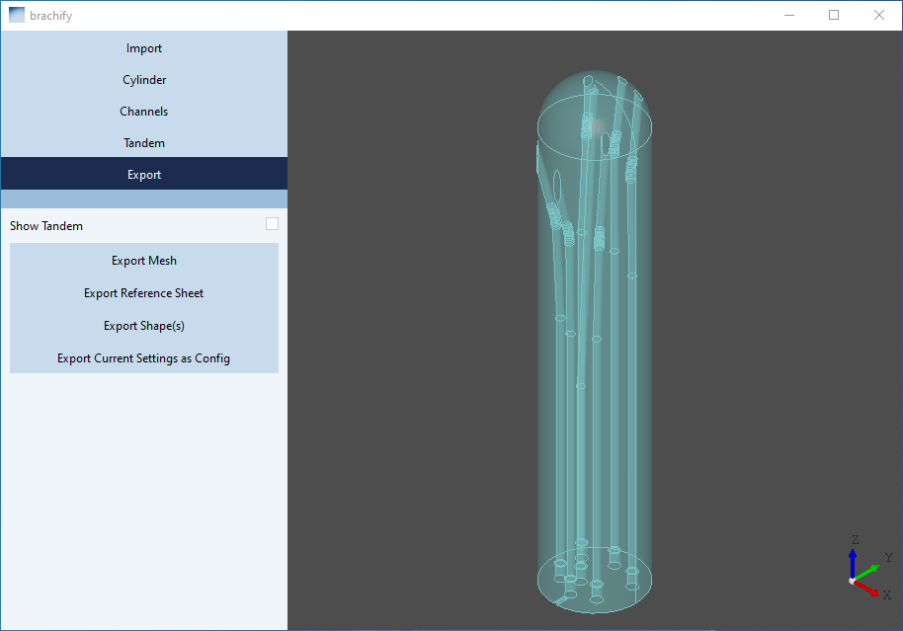
Export
- The display is different for the Export tab than other tabs:
  - The needle channels and tandem cut-out (if applicable) are shown as removed from the cylinder.
  - (See Section 4.3 Display for details)
Export Layout
- Show Tandem checkmark box.
  - Displays how a tandem fits into the tandem cut-out in the printed cylinder.
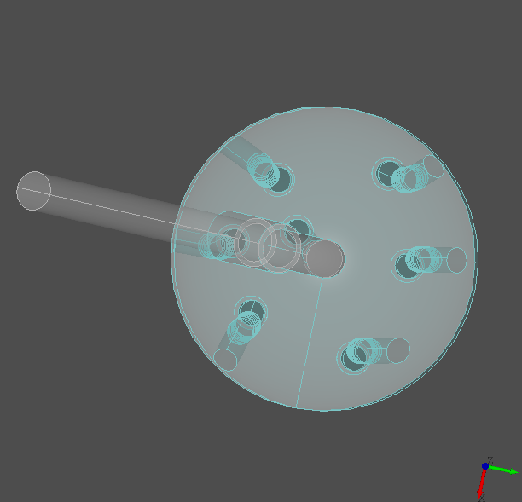
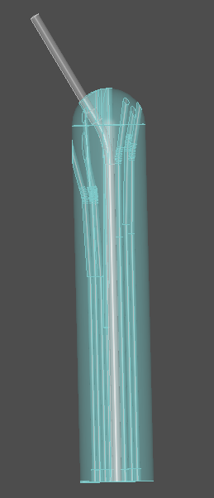
  - Only available if there is a tandem in the model.
- Export Mesh
  - Saves the cylinder as a 3D-printable STL file (.stl).
- Export Reference Sheet
  - Saves a PDF reference sheet containing information about your cylinder model and plan (.pdf).
- Export Shape(s)
  - Saves the 3D cylinder as a shape file (.step or .stp).
- Export Current Settings as Config
  - Saves the current settings as a configuration file (.json)
  - configuration files can be imported (see Section 4.2 Import) so these values are used instead of the default values.

Layout of Brachify
- Import
  - Import Dicom
  - Import Config File
  - Information Panel
    - File path of current DICOM folder
    - Patient Info
    - Channel Info
    - File path of current config files
    - Values loaded into Brachify from the config file
- Cylinder
  - Cylinder Diameter
  - Cylinder Length
  - Add Base
- Channels
  - Channel Diameter
  - Needle Length
  - Threading Depth
  - Threading Diameter
  - Channel List
  - Set as Tandem
  - Enable/Disable
- Tandem
  - Import
    - Import
    - Clear Imported Tandem
    - Height Offset
    - Rotation
    - Apply Import Settings
    - File path of imported tandem
  - Generate
    - Tandem Height
    - Channel Diameter (Tandem Channel Diameter)
    - Stopper Diameter
    - Bend Angle
    - Bend Radius
    - Threading Depth
    - Threading Diameter
    - Rotation
    - Generate Tandem
    - Clear Generated Tandem
- Export
  - Show Tandem checkmark box
  - Export Mesh
  - Export Reference Sheet
  - Export Shape(s)
  - Export Current Settings as Config

